Use-Case Realization Report (Analysis)
View Employee Details

Issue <1.0>
Revision History
Date | Issue | Description | Author
<29/apr/11> | <1.0> | Initial Document | Koh Ming Jin

Table of Contents
1. Brief Description 4
2. Flow of Events 4
2.1 Standard Flow 4
2.2 Exception 4
3. Interaction Diagrams 4
3.1 Collaboration Diagram for View Employee Details 4
4. Participating Objects 4
4.1 View Employee Page 4
4.2 View Employee Page 4
4.3 Employee 4
5. Class Diagrams 5
5.1 Domain Class Diagram: View Employee 5
6. Derived Requirements 5

Use-Case Realization Report
View Employee Details

Brief Description
This use case enables an operation manager to view an employee details record.

Flow of Events
The standard flow of events for this use case and any exceptions are described in the following subsections. See section 3.1 for an overview of the participating Actors and Domain Objects.

Standard Flow
The flow of events is described as follows:

- The use case starts when Operation Manager selects the View Employee Details option of the system.
- The View Employee Page, which includes all the employee details, is displayed.
- The Operation Manager can click on the employee’s ID to view more details about the selected employee.
- The use case terminates.

Exception
- NIL

Interaction Diagrams

Collaboration Diagram for View Employee Details
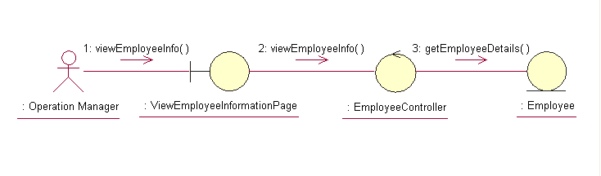

Participating Objects

View Employee Page
This object renders the contents to allow authorized actors to view the employee information. The Director, Department Manager and Operation Manager actors use this object.

View Employee Page
This object acts as the middleman between “View Employee” Page and the Employee object. It will translate interactions with the view into actions to be performed by the Employee object.

Employee
This object stores the details concerning the employee of the COMS.

Class Diagrams

Domain Class Diagram: View Employee


Derived Requirements
The Operation Manager PC keyboard and mouse will be used to retrieve employee details (if any) and view all the system responses.

